As we indicated in the README.txt (please read it first if you haven’t already) our bot plays optimally and never permits us to win. Therefore 4x4 TicTacToe is futile game when we play optimally too.

So the first case: “X wins the game” can never happen in our game since our bot never permits us if we have turn number less than 6. In order to show that case, we have decreased the turn number to 6 (Explained in README.txt what is a turn number and how it is useful). Basically our bot does not calculate the first 6 moves and does not play optimally.

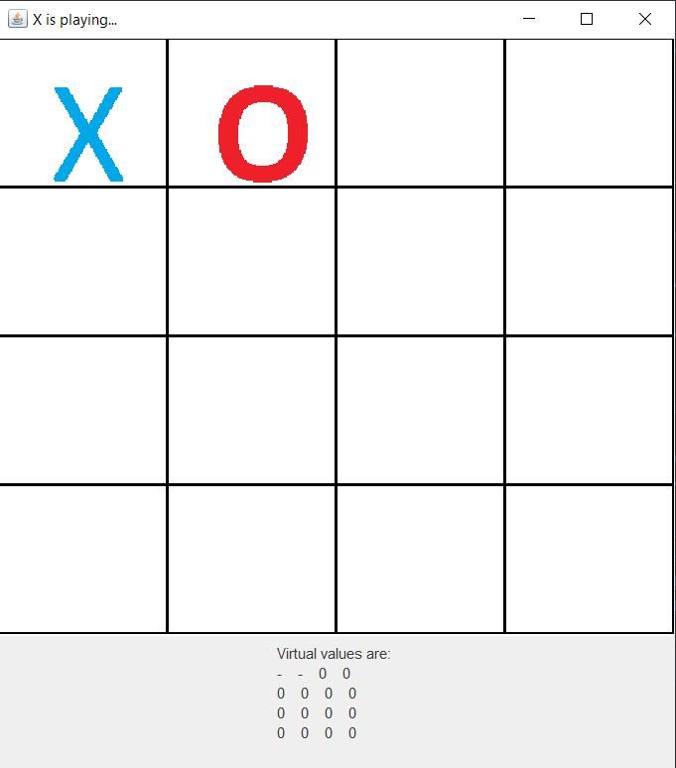
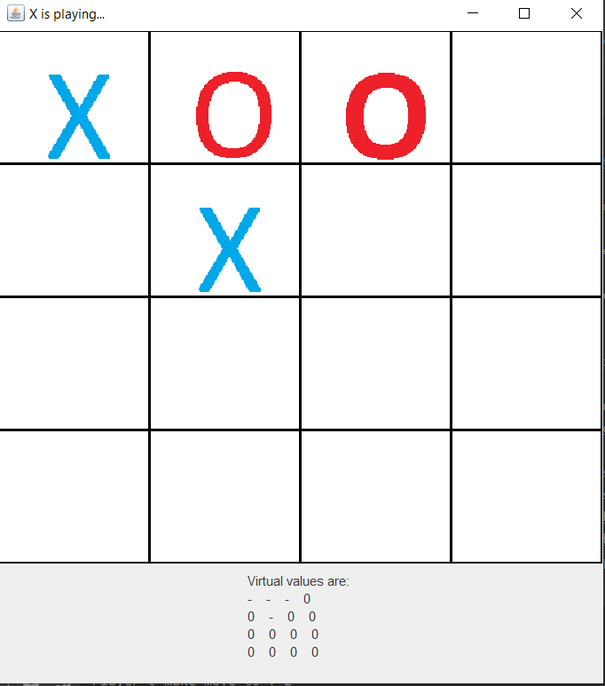

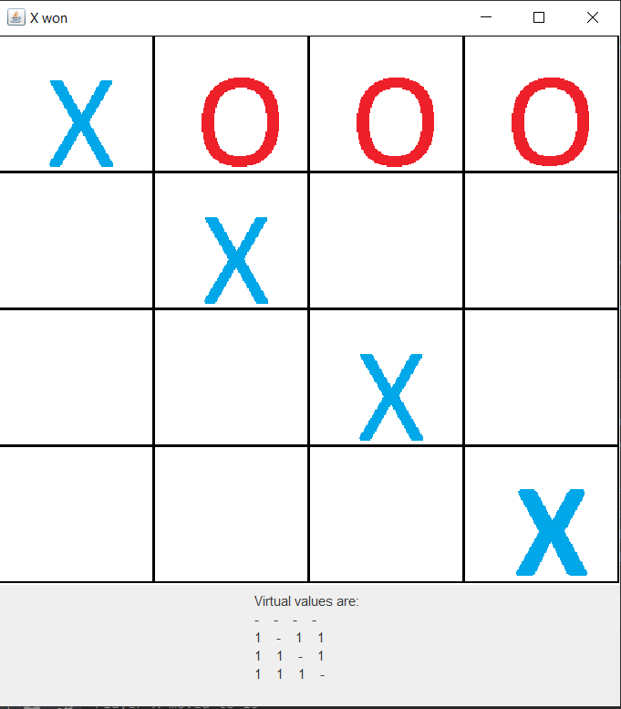
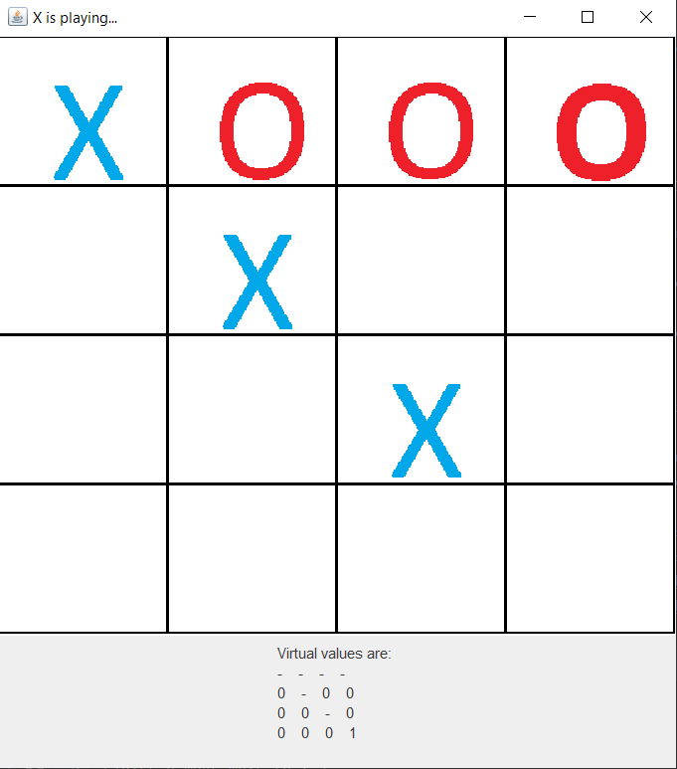

After this point turn number is 3 in these screenshots and that means our bot plays close to optimum.

This is step by step how can we lose the game.
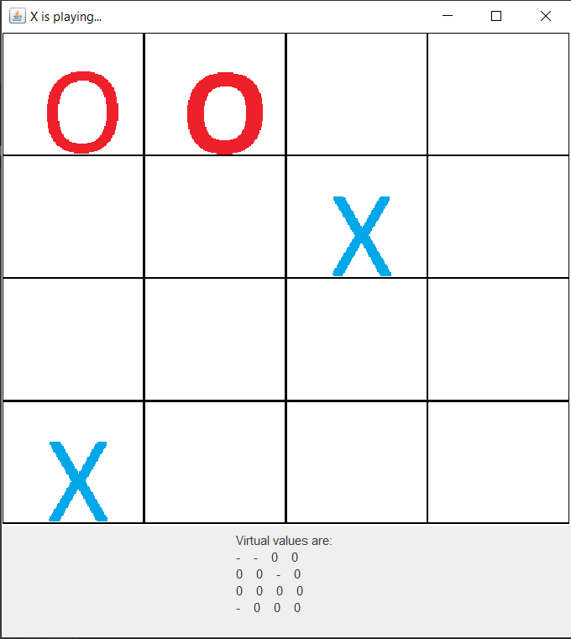
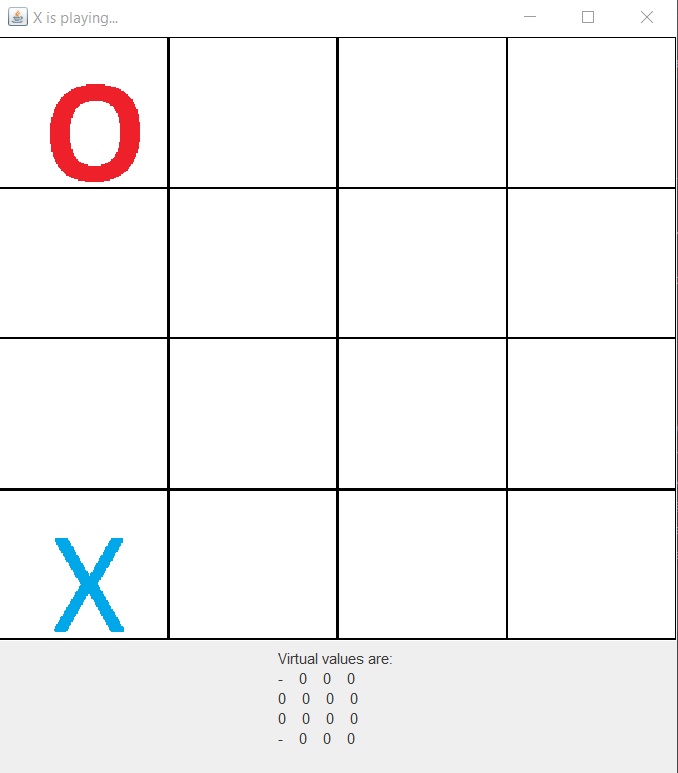

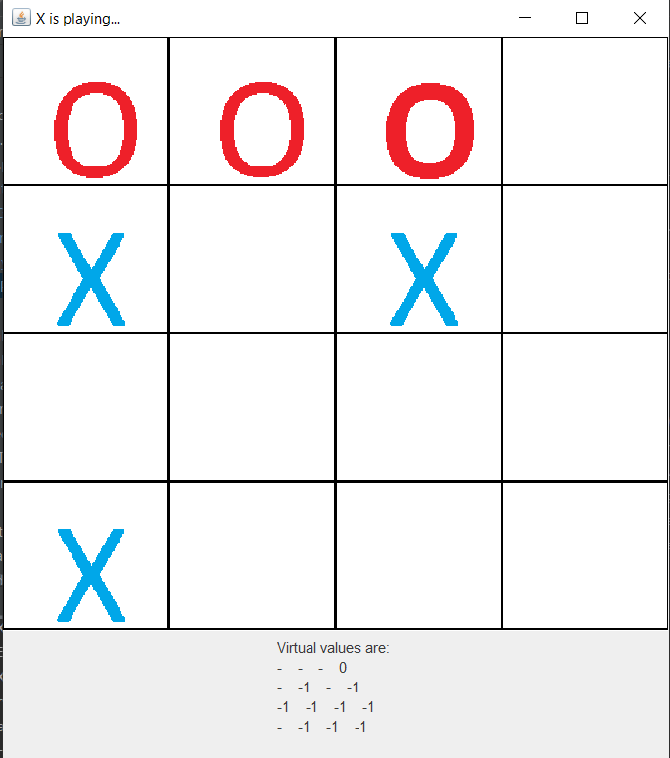
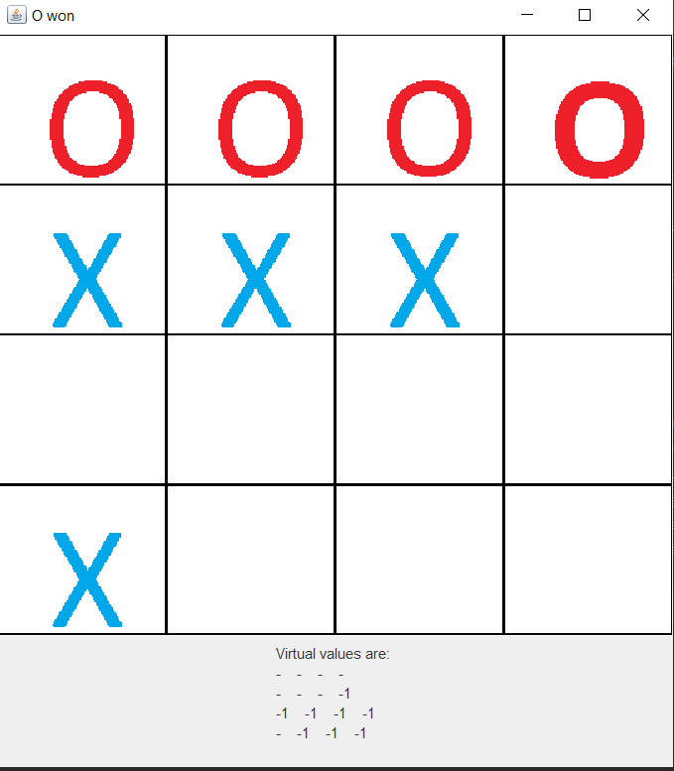

.

As screenshots show, the bot will win the game easily if we play bad.

So let’s play optimal game and see bot always prevents us to win:
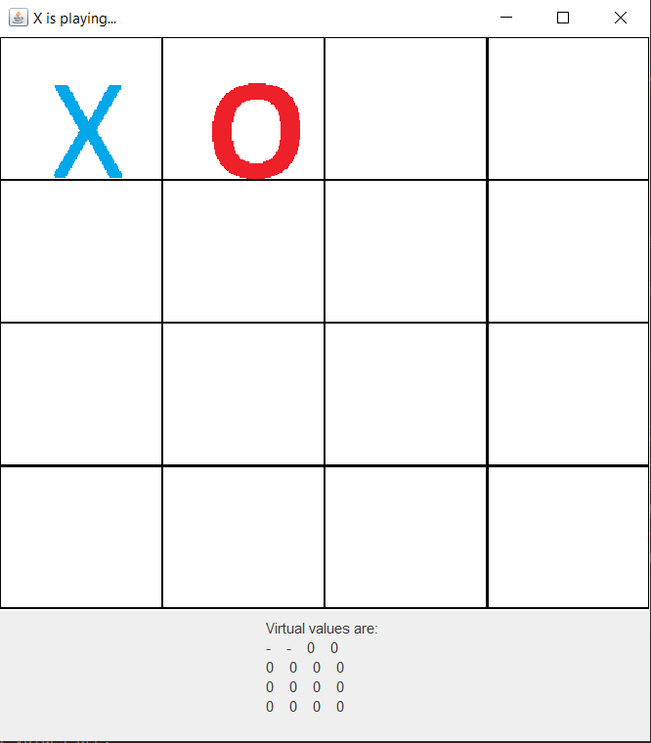
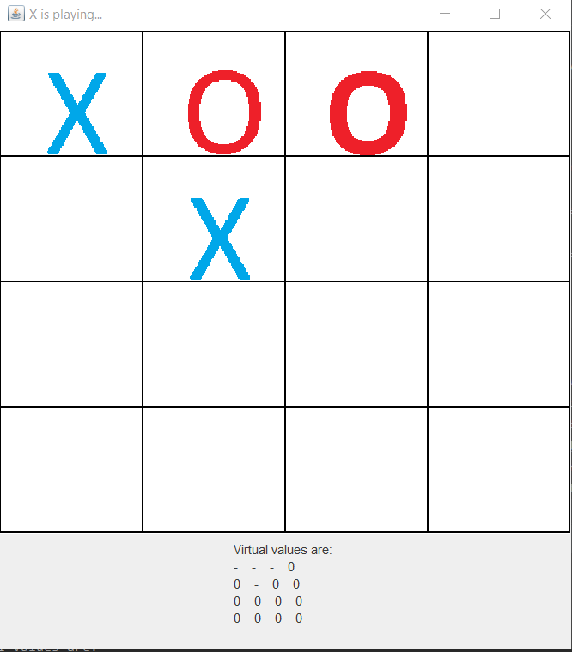
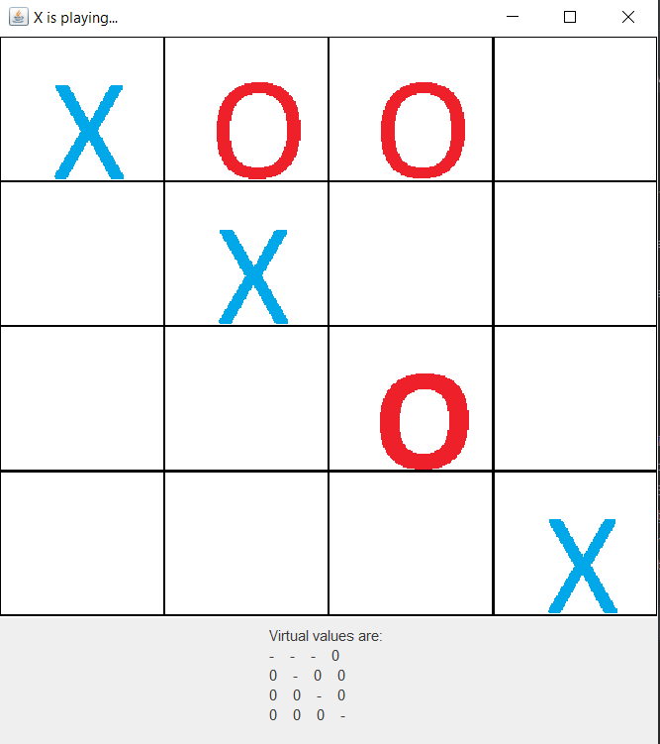
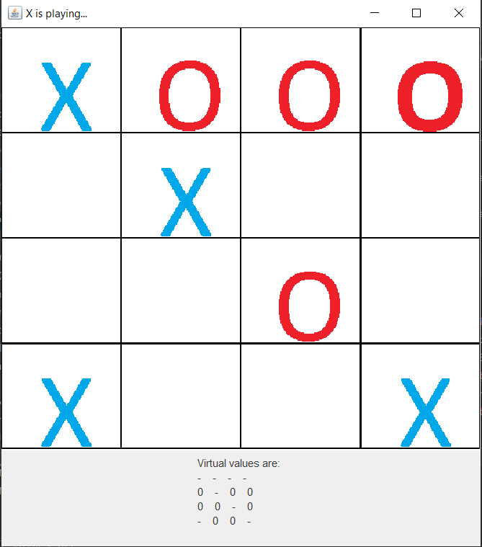
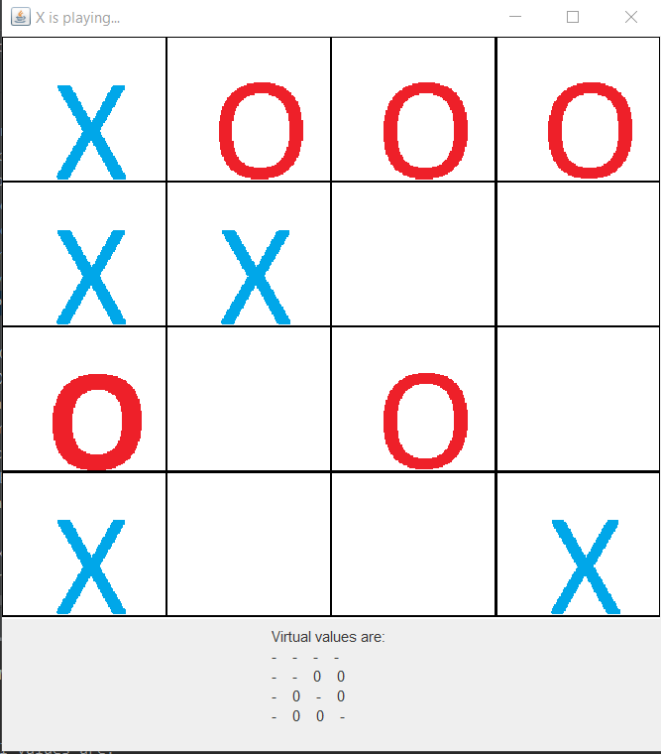
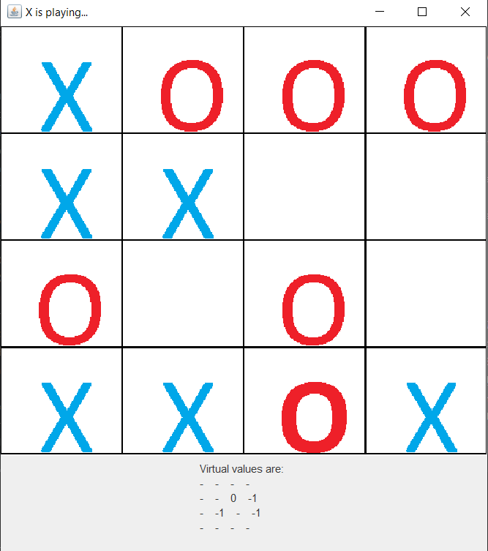

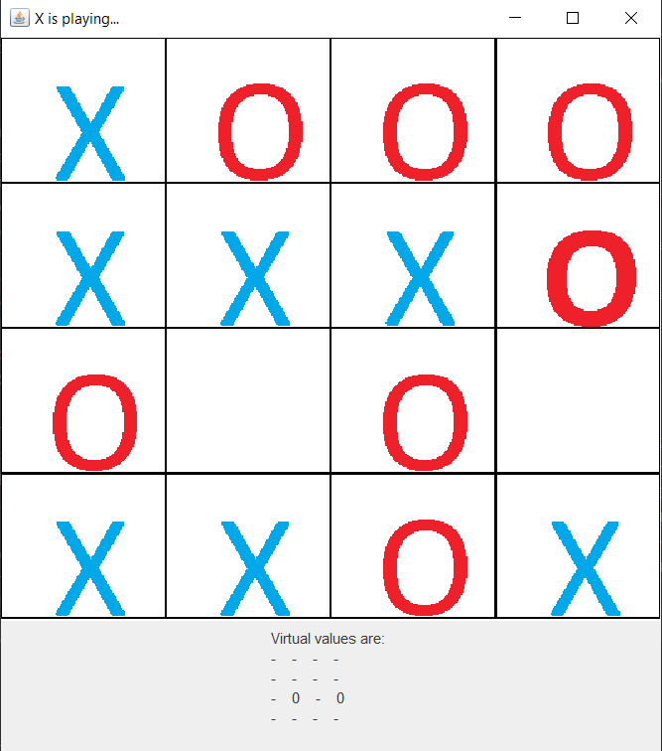
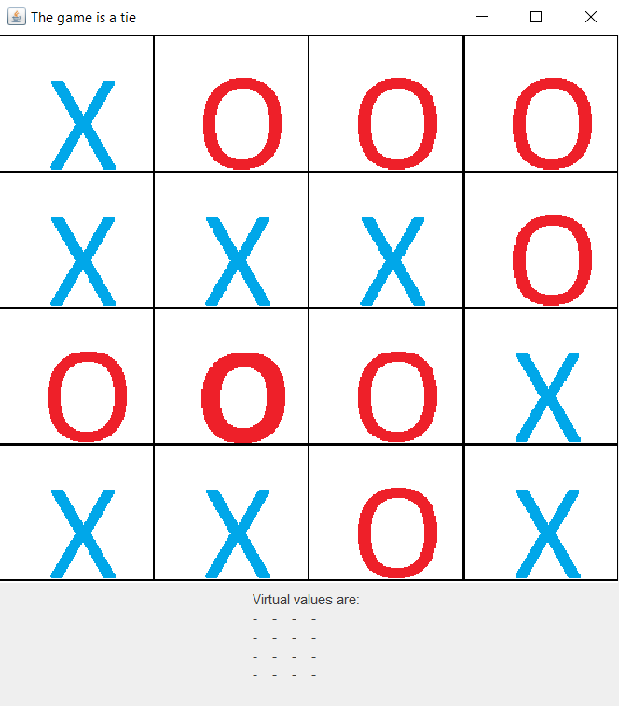

As the screenshots show, the bot always prevents us from the winning.

Therefore 4x4 TicTacToe game is a fultile game if both players play optimally.

